2024/25

School Prospectus
All Saints’ Primary School, Tattysallagh
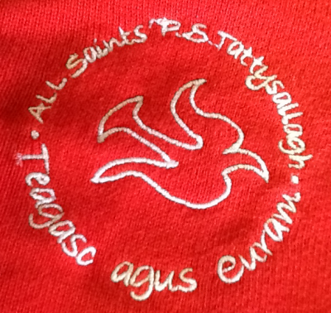
All Saints' Primary School Catholic Maintained
42 Tattysallagh Road Co‐Educational
Omagh Age Range 4‐11
BT78 5BR
Enrolment Number: 111
Tel / Fax No: 028 8224 3233
E-mail: info@allsaints.omagh.ni.sch.uk

Principal: Mrs B Daly Chairperson: Mrs Marie Gallagher
Admissions No:16 Enrolment No: 111

Dear Parent,

May I take this opportunity to thank you for taking the time to read our school prospectus.
Although a prospectus can only give you a flavour of what our school community is like, I hope that it conveys the vibrant, welcoming and nurturing environment that is embedded here at All Saints’.

All Saints’ is a co-educational primary school situated five miles from Omagh. The school was built in 1989/90 and was officially opened on 1st November 1990 by the Bishop of Derry, Edward Daly. In 2016, we opened an extension consisting of a beautiful central resource area specifically for Foundation Stage Play as well as a spacious P1 classroom. It is set in its own spacious, pleasant grounds and boasts many wonderful facilities including an outdoor gym and adventure trail, ICT equipment like iPads and laptops and an environmental learning area including a pond.

Our school motto is ‘Teagasc agus Curam’; a Gaelic phrase which translates as ‘Educate and Care’. This motto reflects the values we hold at All Saints’ P.S. We aim to provide our pupils with a happy, stimulating and secure environment in which each child’s potential is developed to the full.

As a Catholic school our overriding aim is to establish and foster Christian values for life. To do this it is essential that we work in partnership with all our parents and the parish community. Indeed, the success of our school depends on good co-operation between staff, pupils and parents.

Of course no booklet can convey the real atmosphere of a school. I warmly invite you, therefore, to visit the school. We will be most pleased to see you and give you a tour of All Saints’.

With sincere good wishes

Briege Daly
Principal

OUR SCHOOL MOTTO

Dear God,
We want our school to be a happy place
Where God’s love shines in every face.
Where everyone shows respect and care
And in all our choices, God is there.
May your peace and love grow every day
As we follow you Lord,
in our work and play.
Amen

OUR AIMS

Our aim is to provide a caring, secure, Christian community where everyone feels valued, supported and happy.

Working together we will provide an ethos in which honesty, fairness, respect and optimism abound.

Through cultivating high aspirations and a positive sense of self, everyone will set and achieve their highest personal, academic and social goals.

Our values serve as a compass for our actions and they are manifested in our behaviours.

All staff strive to provide an ethos in which honesty, fairness, respect and optimism permeate all relationships within the school community. High aspirations and standards of respect, self-discipline and commitment are sought and everyone is encouraged to set and achieve the highest personal, academic and social goals. The safety, welfare and development of everyone in our school community are of paramount importance to all staff.

In All Saints', the pastoral care structures are based on a shared understanding of what it means to be a Catholic school. We welcome children of all faiths and no faith.

The supportive ethos of All Saints' is tangible within the daily life of our school. Visitors regularly comment on the positive and welcoming atmosphere they experience when they arrive in All Saints'. The school's clear sense of purpose and identity is present among both pupils and staff. We place a high priority on the emotional well-being of both learners and staff and ensure that there is an effective link between the academic and pastoral systems which inform and support target-setting and contribute to improvement throughout the school.

Time, effort and attention are dedicated to ensuring that positive relationships exist at all levels within the school community and this investment is rewarded by staff and pupils consistently working together in a purposeful and supportive manner. Clear and open channels of communication operate at all levels within All Saints'. The school works collaboratively with governors to ensure that the school is seen as vibrant, self-improving, well governed and effectively led.

At All Saints', the ethos is further evidenced through the maintenance and development of a high quality learning environment. During the lifetime of the present school development plan, the learning environment has been considerably updated, enhanced and enriched so that all pupils have access to the best possible learning experiences.

All Saints' has developed and maintained strong links with numerous community organisations and with other schools - nursery, playgroups, primary, post-primary and cross-community. These links strengthen community, ease transitions and promote understanding and trust. The school also networks with outside agencies to ensure that learners benefit from every opportunity to improve.

GENERAL INFORMATION

All Saints’ Primary School officially opened on All Saints’ Day, 1990, replacing Tattysallagh Primary School. It has five classrooms, each equipped with an interactive whiteboard. We also have a staff-room, Principal and Secretary’s office, a central resource/ library area; a spacious area designated for ‘Learning through Play’; a kitchen, a multi-purpose hall with fitted climbing frames; toilets, cloakrooms and a caretaker’s store.

We have a large outdoor area comprising an outdoor gym, an adventure trail, outdoor learning equipment, a spacious playground with areas for sports, for use of the trucks and trikes and cycling proficiency training. We have a grass Gaelic football pitch and an environmental area including a pond, greenhouse, wooded area and bug hotel.

Our current staffing is made up of Principal, one full-time permanent teacher, three part-time permanent teachers, two full-time temporary teachers and one part-time temporary teacher who shares a teaching role with the Principal. The school secretaries, building supervisor, cleaner, classroom assistants, supervisory assistants and school meals staff complete a team dedicated to the education and welfare of children entrusted to their care.

Meals are transported daily from Holy Family Primary School. They are served from 12.00 noon and are supervised by members of staff in the multi-purpose hall. Pupils have a choice of meals or they can opt to bring a packed lunch.

Our enrolment over the years has been very healthy.

Year | Applicants | Accepted
2017-2018 | 15 | 15
2018-2019 | 19 | 17
2019-2020 | 18 | 18
2020-2021 | 17 | 16
2021-2022 | 16 | 16
2022-2023 | 12 | 12

Admission Arrangements for Reception and Year One

The current policy is to admit children into the Year One class on the first day of the Autumn
term, those children who have reached compulsory school age, i.e. those children whose 4th
birthday falls before 2nd July. Digital applications are completed online on the Education Authority website. (www.eani.org.uk)

Induction Programme for Year One

The Induction Programme at All Saints’ is intended to:
- Help both parents and children in the transition from home to school
- Ease the uncertainty of starting school for children especially those who have not been in a formal pre-school setting.
- In June the parents will be invited to the school for an Induction Morning.
- Also towards the end of June, we invite our new P1/Reception pupils in for at least one day.

During the Induction we will:

- Introduce the children to their future classroom, the school principal/ teacher and classroom assistant in an informal manner.
- Give parents the opportunity to discuss any worries they may have about their child starting school.
- Help parents in their role as educators of their children by encouraging active participation in their child’s learning.
- Give guidance and advice, when required, on how best to prepare children for school.

During September we operate a shorter day for pupils in Year 1. This means that the children can gradually adjust to a full day at school. Information will be given to parents regarding these times and the routines of school and the Curriculum in Year 1 Induction Meetings.

ADMISSIONS CRITERIA – YEAR 1/RECEPTION

The Board of Governors of All Saints' Primary School has determined that the following criteria shall be applied by them in the event of the number of pupils applying for places in Year 1 being greater than the admissions number, in the order set down below. Priority shall be given to children who reside in Northern Ireland.

- Children of compulsory school age who live in the traditional catchment area.

- Other children of compulsory school age.

- Should there be places available within the DE approved Enrolment number of 111, pupils will be considered for admission after their 4th birthday as below:

The school will continue to admit children not of compulsory school age as above unless the Department of Education determines that such children will be zero‐rated for funding purposes.

In the event of over‐subscription in any of the above criteria, then the following Sub‐Criteria shall be applied in the order set down:‐

- Children who have older brothers/half‐brothers, sisters/half‐sisters at the school;
- Children whose parents/guardians are employed or appointed to take up a post in the school;
- Children with a specific family connection (ie older brother/half‐brother, sister/half‐sister, mother/father or guardian were past pupils);
- Other children.

In the event of over‐subscription in any of the Sub‐Criteria, final selection will be on the basis of the closeness of the home to the school as measured by the shortest walking distance.

YEAR 1 ADMISSIONS – AFTER THE BEGINNING OF THE SCHOOL YEAR

Children who apply to enter the school during the academic year will be considered using the same criteria as for Year 1.

ADMISSIONS CRITERIA – YEARS 2-7

Pupils will be considered for enrolment provided that:

- the school would not exceed its enrolment number; and
- in the opinion of the Board of Governors their admission would not prejudice the efficient use of the school's resources.

If, at the time of the consideration of the application, there are more eligible applicants than places available then the Admissions Criteria for entry to Year 1 of pupils of compulsory school age will be applied.

Year | Total Applications | Total Admissions
Year 2020/2021 | 17 | 16
Year 2021/2022 | 16 | 16
Year 2022/2023 | 12 | 12

BOARD OF GOVERNORS

The Board of Governors plays a full role in the life and work of the school. Members of the Board of Governors are volunteers from the local community. The Board also includes staff and parental representatives who are elected every four years.

Individual members of the Board have experience in the areas of business, finance and education and are able to draw upon these experiences when carrying out their duties. Each member on the Board has a specific responsibility for a designated area, e.g. Child Protection.

The current Board membership of All Saints’ P.S. is as follows:
Chairperson | Mrs Marie Gallagher
Vice-Chair | Mrs Brendan McGrath
Secretary to Governors/ Principal | Mrs Briege Daly
Teacher Representative | Mr Gary McKenna
Parent Representative | Mrs Kathleen Gallagher-Arruda
ELB Representative | Mr Brendan McGrath
ELB Representative | Mr Gerry Broderick
Trustee | Mr Gary Campbell
Trustee | Mrs Christine McLaughlin
Trustee | Mrs Una Barrett
Co-opted member | Fr. Eugene Hasson

SCHOOL STAFF
Principal / Teacher | Mrs Briege Daly
Teachers | Mrs Caitrín Boggs  Mrs Brenda McGrath  Mr Gary McKenna  Miss Megan Loane  Miss Emma Kirk
Secretaries | Ms Marie Campbell  Ms Fiona Robinson
Classroom Assistants | Mrs Audrey Campbell  Miss Claire McLaughlin  Mrs Karen McLaren  Mrs Emma Graham  Mrs Brenda Breen (temp)  Miss Catherine Campbell (temp)  Mrs Shannon McGowan
Lunchtime Supervisor | Mrs Audrey Campbell  Miss Claire McLaughlin  Mrs Shannon McGowan  Mrs Karen McLaren
Canteen Assistant | Collette
Building Supervisor  Cleaning staff | Mr Charles Quinn  Mrs Christina Devlin

SCHOOL HOURS

The school day begins at 9am. Staff supervision is available in the assembly hall from 8.10am, for pupils who arrive at school early. Breakfast Club begins at 8.15am. Pupils arriving at school before 8.45am should go to the school assembly hall. The morning mile starts at 8.50am. All pupils should be in their classrooms by 9.00am.

Break-time is from 10.45am to 11.00am. On wet/icy days pupils remain in their classroom, supervised by a member of staff. During this time, pupils are able to play a variety of games, iPads and may have access to the indoor play equipment in the assembly hall.

Lunch-time begins at 12.15pm and ends at 1.00pm. Pupils are supervised in the dinner hall and outside by various staff.
The school day ends at 1.00pm for pupils in Reception class. During the month of September, pupils in Year One also go home at 1.00pm. Pupils in Years One (from October on) and Year Two go home at 2.00pm. Pupils in Years Three – Seven go home at 3.00pm.
Pupils are collected at the classroom entrance of the school and are accompanied by their teacher until their lift arrives.
Pupils will not be allowed to leave the premises early during the school day without a written note from their parent/guardian or without first receiving permission from the Principal. In the interests of safety, if a pupil is required to leave the school early, they must be collected by their parent/guardian from the school foyer and will not be permitted to leave the school grounds unaccompanied or wait outside the gate.

ATTENDANCE
It is most important that your child comes to school every day to ensure that he or she makes maximum progress and develops self-confidence and friendships with others. We do realise that there are times when due to illness school is not a suitable environment and it is better and desirable that the child stays at home until he or she is feeling better and able to enjoy taking part in all the learning experiences.

All pupils should attend school for 185 days less exceptional closures, which the law requires. Should a child be absent from school for any reason, parents should provide a note of explanation. In the interest of safety, no child is allowed to leave class at any time without permission from the school.

SCHOOL UNIFORM
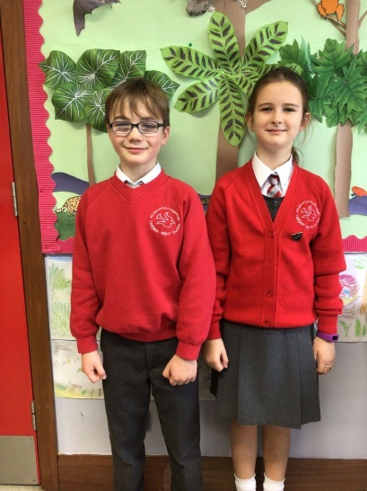
Our school uniform consists of:
- Red V-neck jumper/cardigan with school logo;
- White shirt/blouse;
- Red and grey striped tie;
- Grey skirt/ pinafore or trousers for girls and grey trousers for boys;
- Girls may wear white socks or red/grey/white tights.
- A school hoodie is also available to order
In warmer weather girls may wear red and white checked summer dresses and boys may wear grey shorts.
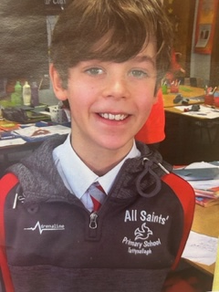
For PE, pupils should bring:
- A red polo shirt and black shorts;
- Plimsolls or trainers;
- A separate bag for PE gear so that it can be kept in school.
An old, oversized shirt or T-shirt can be used for art activities to protect clothing. Alternatively, you can purchase a plastic apron with sleeves.
All items are available from Select Kidz in Omagh. Tel: 028 8224 0289. Half-zips can be ordered from MFC through the school office and include your child’s initials.
It is important to have all items labelled clearly with your child's name.

THE CURRICULUM
Children in All Saints’ Primary School are offered a varied and interactive curriculum, tailored to their individual needs, abilities and interests. Every effort is made to link the learning in the classroom with the skills and knowledge required by the children in every-day life.

There is a strong focus on equipping every child with high level skills in Literacy/ Numeracy and ICT. Traditional teaching methods are combined with the use of new technologies and interactive strategies for learning.

In All Saints’, we aim to develop each child as a confident and independent learner. As the children progress through the school they are encouraged to take increasing responsibility for evaluating their own learning.

There are three distinct stages covered from 4-11 years.

- The Foundation Stage consists of Reception, Year 1 and Year 2.
- Key Stage One – Year 3 and 4
- Key Stage Two- Years 5, 6 and 7.

The N.I. Curriculum is made up of a range of learning areas which foster attitudes and dispositions. These incorporate assessment for learning which aims to promote and encourage learning experiences. These include the following:

Whole Curriculum Skills and Capabilities
At the heart of the curriculum lies an explicit emphasis on the development of skills and capabilities for lifelong learning and for operating effectively in society. Through opportunities to engage in active learning contexts across all areas of the curriculum, children at All Saints’ progressively develop:

Cross-Curricular Skills:
- Communication
- Using Mathematics
- Using Information and Communication Technology

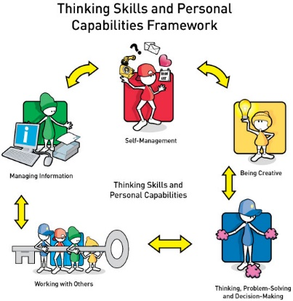
Thinking Skills and Personal Capabilities:
- Thinking, Problem-Solving and Decision-Making
- Self-Management
- Working With Others
- Managing Information
- Being Creative

The seven learning areas within the curriculum are:
- Language and Literacy
- Mathematics and Numeracy
- The Arts
- The World Around Us
- Personal Development and Mutual Understanding (PDMU)
- Physical Development
- Religious Education

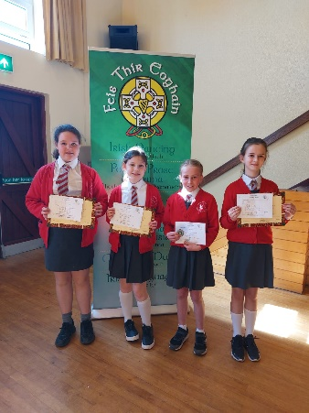
Language and Literacy (including Talking and Listening, Reading and Writing);

Literacy focuses on developing each child’s ability to understand and use language, both spoken and written, as an integral part of learning in all areas. The development of language and literacy is crucial to living and learning.

In All Saints’ P.S., we use the following programmes to complement our Literacy Scheme:

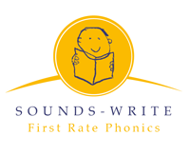
- Sounds-Write Phonics
- Reading Partnerships
- Paired Reading
- Accelerated Reading
- Opportunities for taking part in Poetry recitation at the Feis.

Mathematics and Numeracy (focusing on the development of mathematical concepts and numeracy across the curriculum);

Mathematics is important in everyday life. Through teaching and learning in this area we aim to develop children’s confidence and enthusiasm in using and applying mathematical skills and knowledge to the world around them.
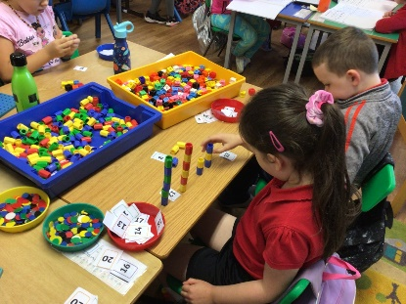
The children are provided with valuable practical experiences which enable them to develop:
- Processes in Mathematics
- Number
- Measures
- Shape & Space
- Data Handling
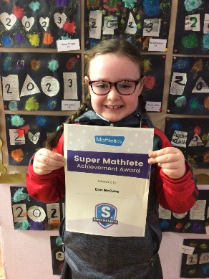
We recognise the importance of cross-curricular links with Literacy, World Around Us, ICT and other subjects, and opportunities to apply numeracy skills across the curriculum are promoted by teachers.

We also make use of the following Numeracy resources to supplement our scheme:
- Numicon
- Mathletics
- Izak 9

The Arts (including Art and Design, Drama and Music);

Children are able to express their ideas, feelings and interpretations of the world in diverse ways by developing their creativity through Music, Drama, Art and Design. Children at All Saints’ are able to develop drama skills through a range of hot-seating and film-making opportunities, as well as assemblies, Christmas shows and literacy activities.

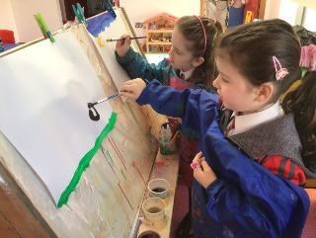
Tin-Whistle and singing is taught in Years One to Seven, on a Monday afternoon by our Music tutor, Mrs Nuala Sweeney. Pupils in Years Three to Seven may also have the opportunity to be part of the school choir, who sing at various masses and special occasions throughout the year. We incorporate the playing of traditional instruments and regularly have used this to accompany our choirs. Pupils can also avail of music tutors for other instruments also. Art and Design is a very important aspect of All Saints’ P.S. Pupils have opportunities to explore a variety of art mediums such as paint, clay, 3D construction and textiles as well as exploring the work of many artists. They plan, create and evaluate their own pieces of work which can often be displayed on our colourful walls in school. Pupils also participate in the West Tir Eoghain Feis each year, which we are always very successful in.

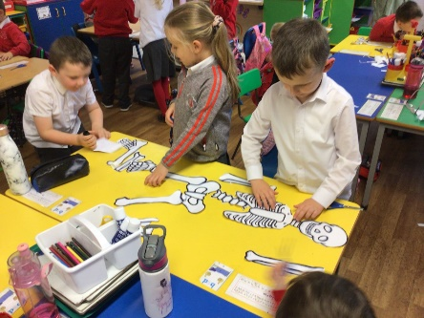
The World Around Us
The World Around Us is the study of Geography, History, Science and Technology throughout all key stages and is planned to connect learning across the three areas mentioned above. Children are provided with opportunities to develop their skills through a range of topics. The learning is supported by trips which enhance children’s experiences and opportunities for learning.

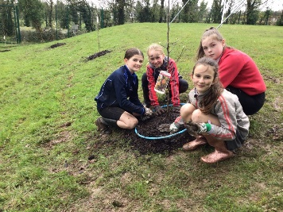
As an Eco-School, our school is dedicated and committed to eco-values which are developed through our Eco-Council. We are lucky to have a wonderful environmental area comprising of a pond and woodland area. We proudly achieved the Eco Schools Green Flag in 2021.

STEM (Science, Technology, Engineering and Maths) is another area within the WAU that we strive to develop at All Saints’. We have an array of fantastic resources for the development of this learning area and participate in STEM challenges in local Post-Primary schools.

All Saints’ are proud to have achieved ‘Outstanding’ in a focused inspection on World Around Us by ETI in 2016.

Personal Development and Mutual Understanding
Personal Development and Mutual Understanding (PDMU) focuses on encouraging each child to become personally, emotionally and socially effective, to lead healthy, safe and fulfilled lives and to become confident, independent and responsible citizens, making informed and responsible choices and decisions throughout their lives.
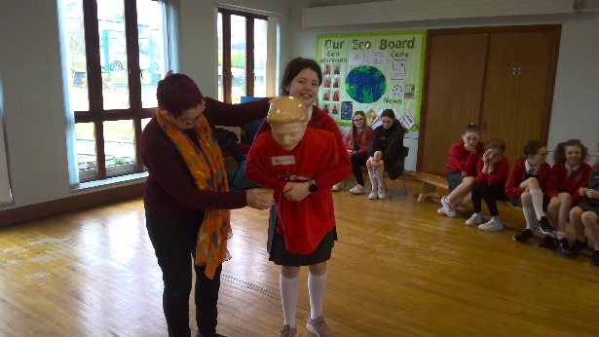
We develop PDMU through a variety of initiatives including:
- School Council;
- NSPCC;
- Action Mental Health;
- PSNI/ NHS visits;
- NIFRS and DOE Road Safety;
- Helping Hands programme;

Physical Education (focusing on the development of knowledge, skills and understanding through play and a range of physical activities)

Through the Physical Education Curriculum, the pupils develop physical and sporting abilities through athletics, swimming, dance, games and gymnastics.

Pupils at All Saints’ benefit from a range of outside agencies, who work in partnership with the school to develop P.E., including:

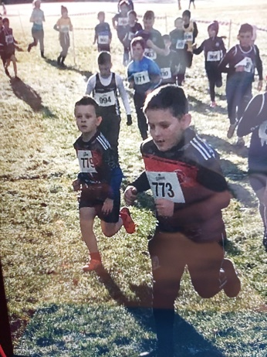
- Tyrone GAA coaching;
- Omagh Leisure Complex Swimming Programme;
- Dance with Chris Cross;
- AB coaching.

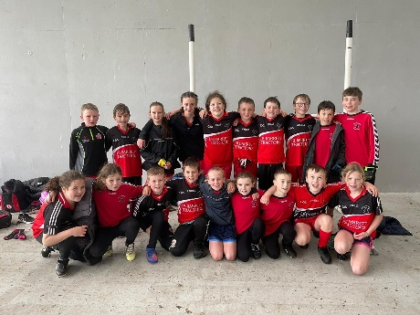
The pupils also participate in extra-curricular sporting activities which can include:

- Gaelic;
- Netball;
- Hurling;
- Cross Country Running;
- Competitive Blitzes;
- Games.

Religious Education

Catholic ethos permeates all aspects of school life in All Saints’. Religious Education is taught through the Grow in Love Programme as well as other Diocesan/ teacher made resources.
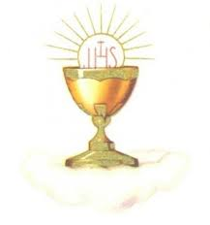
Parents are encouraged to become involved in the preparation of their children for the sacraments of Reconciliation, Holy Communion and Confirmation through the Parish Sacramental Programmes ‘Do this in Memory of me’ and during special preparatory masses including ‘Service of Light’ and the ‘Pledge’ mass.

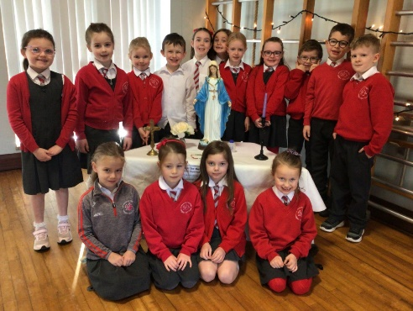
Assemblies are held monthly and each class proudly presents these assemblies based on various religious themes throughout the year, e.g. forgiveness, the Holy Spirit and generosity. Mass and other religious ceremonies are offered at special times of the year. These liturgies encourage the active involvement of the pupils, parents and staff. We see the school as a vital part of the Parish of Drumragh and take every opportunity to contribute to the life of the parish. Our priests, Fr. Hasson and Fr. McCaul, visit the school regularly and play a very full and active role in the life of the school. As an inclusive school, we are respectful of all faith backgrounds and can work with parents to accommodate alternative faith development.

Using ICT

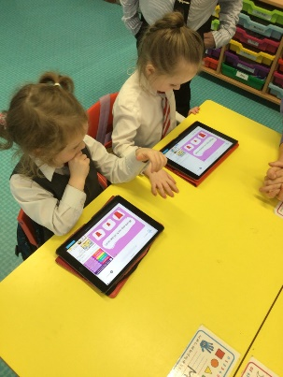
Using ICT (Information and Communications Technology) describes the ability to handle and communicate information, solve problems, pose questions and be creative through the use of technology.

Pupils in All Saints’ have opportunities to transfer their knowledge, understanding and skills in a variety of meaningful contexts across the curriculum, including collaborating inside and outside the classroom; sharing and exchanging work and exhibiting and showcasing their learning.

We have an array of ICT resources including a suite of Chromebook laptops for classroom use; iPads equipped with a range of educational apps; desktop PCs equipped with the latest C2k software; Smartboards in every classroom and as well as other technologies such as interactive devices and tablets.

We use ICT to showcase our pupils’ learning through online learning platforms, Seesaw and Microsoft Teams. These are the platforms used in the event of home learning and may be used from time to time for homework.

Assessment and Reporting Procedures

Children are continuously assessed using a variety of formal and informal testing. Assessment for Learning is an integral part of the Curriculum. We see assessment as an integral part of the learning process, as children are actively involved in their own learning.

We ensure that children are given effective feedback which challenges and improves the quality of children’s work as well as giving children an immediate and positive boost to their self-esteem. We also encourage children in the use of peer and self-assessment so that they can improve their own and others work.

The school also tests children regularly to ensure that they are making appropriate progress.
These tests are carried out systematically throughout the year and a summative assessment is carried out at the end of the year. The results of these tests are available to parents at any time. Records of attainment and progression are kept on each child and are used to inform teacher’s planning for the future needs of each child.

Teachers meet with parents in the autumn term and will discuss the work that their child will be doing during that year. This also gives the teacher and parents an opportunity to discuss any difficulties the child might be having.

In the summer term, parents will receive a written report on their child, which will comment on the child’s progress in all curricular areas as well as pastoral / behavioural comments. Teachers will also comment on a focus for development for the child so that parents are aware of areas their child can improve on to develop their potential.

At the end of each Key Stage the children take part in statutory assessments in Using Mathematics, Communication and in Using ICT.

Special Educational Needs

The identified educational needs of each child will be catered for by each individual class teacher. Children with special educational needs will be identified through teacher observation, assessment and performance in various tests. Parents will be made aware of any concerns as soon as possible, and in accordance with the Code of Practice, the identified educational needs of each child will be catered for by his/her class teacher. An ‘Personalised Learning Plan’ will be drawn up to ensure that the needs of the child are fully met. This will be supported by our SenCo (Special Educational Needs Coordinator.) We also consult with the specialist services provided by the EA, the educational psychologist and the school's medical service, as well as all other relevant outside agencies. The school is also committed to the inclusion of those with disabilities and to meeting the requirements of the Special Educational Needs Disability Order. (SENDO)

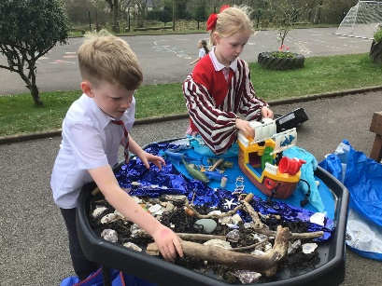
Learning through Play

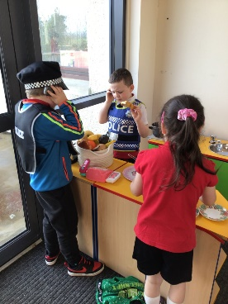
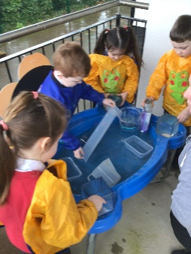
The creation of a distinct Foundation Stage within the NI Curriculum allows us to provide an environment which is more appropriate for our 4 - 6 year olds. Greater emphasis is placed on practical work and on the 'foundations of learning'. This takes the form of what has become known as 'Learning through Play' and forms a large part of our youngest pupils' day. Play is the children's world, it's at the core of their learning and through it they gain confidence and independence. We simply enhance this by putting a very definite structure in place so that, unbeknown to the children, certain specific skills are being developed.

Activity-based learning/practical work in the upper school develops the children's intellect, language skills and imagination, thereby helping them to develop socially, emotionally and physically. Through this important area, the children discover what they can do and how they think and feel.

Through these two important areas, children will develop communication, numeracy, computer and thinking skills. The learning becomes more child-centred and relevant, giving our pupils the skills necessary for future challenges.

HOMEWORK

Homework is given Monday-Thursday to all children and the amount given will depend on the year group your child is in. The main purpose of giving homework is to familiarize you with the work your child is doing in school, to consolidate new information skills and to give the children a chance to work independently. The period of time a child should spend at homework will vary from child to child but guidelines are set out in the school’s homework policy which is available from the school.

The homework will include written, mental and oral work - children may be asked to read, learn tables and spellings, complete set exercises in Numeracy and Literacy as well as practising musical instruments or undertaking research. More information may be obtained in the Homework Policy.

Pupils in Key Stage Two are provided with a Homework Diary that is divided into weekly units. We ask that you check and sign this diary, as well as the homework itself each night. If at any time your child is having difficulty with their homework please inform the class teacher as soon as possible so that the matter may be addressed.

POSITIVE BEHAVIOUR

Good behaviour in any school is central to providing a good learning environment. Here in All Saints’ we believe in positive approach to discipline. We have a whole school approach to promoting positive behaviour which stems from our four school rules which are displayed in every classroom. Pupils are rewarded for observing these rules through Golden Time on a Friday afternoon, ‘house points’, Star prizes within their classrooms and other class/ whole school rewards.

PROMOTING HEALTH AND WELL-BEING
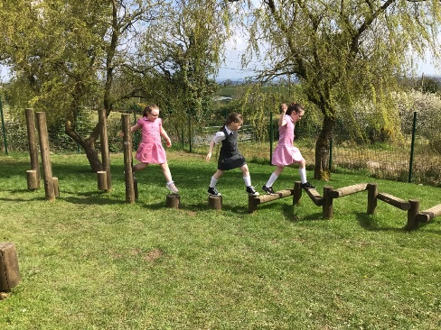
Strategies to promote the health and well-being of our pupils are employed by All Saints’ P.S. on a daily basis. As a health-promoting school, we have implemented a ‘Healthy-Break Policy’ where we encourage pupils to eat healthy snack as part of their morning break. Pupils can also avail of milk as part of their break, which can be paid termly. Pupils are also encouraged to drink still water throughout the day.

At dinner, pupils have the option of choosing from a hot dinner or a packed lunch. We work closely with the EA’s school meal’s staff to encourage healthy eating at lunch time. We offer guidance to parents each year on healthy options for their children’s lunches and we monitor this regularly.

We also promote health and well-being through:
- use of our vast outdoor play area including outdoor gym and adventure trail;
- Daily Mile;
- participation in external sporting events and Sports Day;
- PE programme including external coaching;
- Mindfulness workshops/ programmes;
- Regular snack and lunch monitoring;
- EA online programmes for parents on health and wellbeing.

PASTORAL CARE AND CHILD PROTECTION

The pastoral care of your child is our number one priority at All Saints’. We want your child to feel safe and secure so that they can realise their full potential. Pupils at All Saints’ have
opportunities to participate in pastoral care programmes such as DOE Road Safety, Helping Hands and NSPCC workshops.

Every opportunity is taken at All Saints’ to celebrate children’s achievements. We celebrate achievements outside of school, e.g. sporting achievements on our ‘Achievements’ display/ online learning platforms.

The welfare and protection of children is of critical importance in All Saints’. We have a very active Child Protection Policy in place which ensures that all our children are protected and are safe at all times. The Safeguarding team at All Saints’ consists of Mrs Daly, the Designated Teacher for Child Protection; Mrs Boggs, the Deputy Designated Teacher; Mrs Christine McLaughlin and Brendan McGrath, the Designated Governors for Child Protection and Mrs Marie Gallagher, the Chairperson of the Board of Governors.

All parents receive a Parent Information Booklet which outlines Child Protection in more detail. Additional copies of this booklet are available from the school office and our Child Protection Policy is available to download from our school website.

How a Parent can make a Complaint/Voice a concern about Child Protection

CHARGING AND REMISSIONS POLICY

In line with the requirements of the Northern Ireland Education Reform Order 1990, it is the policy of the Board of Governors to:

- Maintain the right to free school education for all pupils;
- Establish that activities organised wholly or mainly during school time should be available to all pupils;
- Require parents to pay charges for board and lodging for their children, on residential trips, taking account of any relevant remission arrangement;
- Confirm its right to invite voluntary contributions for the benefit of the school or in support of activities organised by the school;
- Make charges in respect of optional extras, as determined by the Board of Governors.

The school may take part in optional extras which are not connected with the school’s formal curriculum. Such visits in the past have included school trips and educational visits. Charges will be made for these but it is again stressed that failure to participate in these will not affect a child’s performance in school. Written parental consent must be received before a child participates in school trips.

FRIENDS OF ALL SAINTS’

Friends of All Saints’ is a parent support group who were set up to:

- Raise funds to help the school provide extra resources for pupils;
- Organise social events for fundraising and just for fun, including the annual Christmas events and summer fun day.
- Provide support for school trips.

Parents are given the opportunity to join the group at the start of each school year, however, parents may join at any time throughout the year by contacting Mrs Daly or the School Office. All parents are encouraged to be fully involved in the activities of the association.

EXTRA-CURRICULAR ACTVITIES
The school boasts an extensive programme of after-school activities throughout the year including:

- Foundation Stage After-School Club (2-3pm daily);
- Sports (Gaelic, Hurling/Camogie, games)
- Irish Dancing with Patricia Wilson School of Dancing;
- Gardening.

After-school activities for Years 3-7 begin at 3.00pm and end at 4.00pm.

LINKS WITH THE COMMUNITY
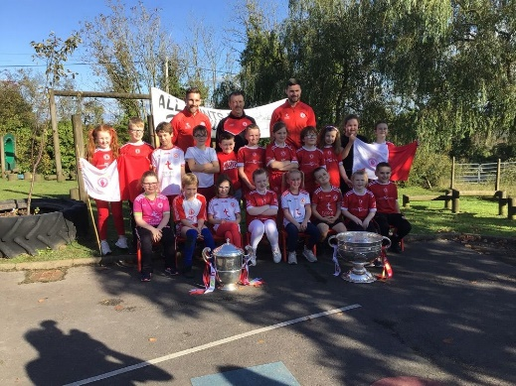
At All Saints’, we pride ourselves with our strong community links.

We link with the local GAA club, Drumragh GFC and support each other at various fundraising events.

We also have a strong link with Tyrone GAA where we link up for coaching and a variety of blitzes throughout the year as well as other neighbouring clubs.

We enjoy having members of our community visit the school on special occasions, such as Prize-giving, Grandparents Day and Graduation as well as other occasions.

We have strong links with various nursery schools and child care centres including Puddleducks and Cornabracken.

LINKS WITH POST-PRIMARY SCHOOLS

All Saints’ P.S. appreciates that transition from primary to post-primary can seem daunting to our young Year 7 pupils. To ease this transition, we have built up strong links with our local post-primary schools. Each year, Year 8 teachers from local post-primary schools in both Omagh and Dromore visit our Year 7 pupils to introduce themselves and tell them about what Year 8 will be like in that school. We also enjoy visiting the schools for a variety of events such as sports blitzes, math competitions and technology projects.

We are a progressive, forward-thinking school and we strive to ensure that our pupils have a happy, successful and rounded experience of primary school learning which will equip them to be contributors to their community and society in the future and will provide them with skills to become life-long learners.

We hope that our prospectus has been informative.

Keep up to date with all school news and events by following us online:
Facebook: @friendsofallsaintsps
Website: www.allsaintstattysallagh.com

